Survey on Machine Learning Algorithms

|  |  |
| --- | --- |
| S.Jayendran | Dr.V.Praveena |
| *Under Graduate student* | *Associate professor* |
| *Department of Information Technology* | *Department of Information Technology* |
| *Sri Shakthi Institute of Engineering and Technology* | *Sri Shakthi Institute of Engineering and Technology* |
| *Coimbatore,Tamil nadu,India* | *Coimbatore,Tamil nadu,India* |

***Abstract* - The objective of machine learning is to program PCs to utilize case information or past experience to take care of a given issue. Numerous effective utilizations of machine learning exist as of now, including frameworks that investigate past deals information to anticipate client conduct, upgrade robot conduct with the goal that an assignment can be finished utilizing least assets, and concentrate learning from bioinformatics information. Prologue to Machine Learning is an exhaustive course book regarding the matter, covering an expansive cluster of themes not normally incorporated into initial machine learning writings. To exhibit a brought together treatment of machine learning issues and arrangements, it talks about numerous techniques from various fields, including insights, design acknowledgment, neural systems, computerized reasoning, flag handling, control, and information mining.**

I. Introduction

Machine learning is a subset of man-made reasoning in the field of software engineering that regularly utilizes measurable procedures to enable PCs to "learn" with information, without being expressly customized. Machine learning is firmly identified with (and regularly covers with) computational measurements, which likewise centers around expectation making using PCs. It has solid connections to scientific advancement, which conveys techniques, hypothesis and application spaces to the field. Machine learning can likewise be unsupervised and be utilized to learn and build up pattern social profiles for different elements and after that used to discover significant irregularities.

*A. Supervised Learning Algorithms*

1*. Linear Regression*

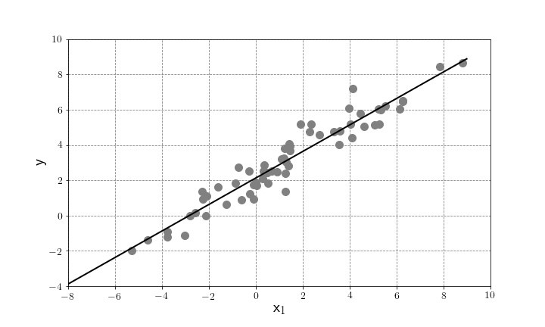 In measurements, direct relapse is a straight way to deal with displaying the connection between a scalar reaction (or ward variable) and at least one informative factors (or free variables).[1] The instance of one illustrative variable is called straightforward straight relapse. For in excess of one illustrative variable, the procedure is called various direct relapse. This term is particular from multivariate straight relapse, where various related ward factors are anticipated, instead of a solitary scalar variable.[2]

Fig.1 Best fit linear regression graph

*Pros:*

Linear regression is an extremely simple method. It is very easy and intuitive to use and understand. A person with only the knowledge of high school mathematics can understand and use it. In addition, it works in most of the cases. Even when it doesn’t fit the data exactly, we can use it to find the nature of the relationship between the two variables.

*Cons:*

1.By its definition, linear regression only models relationships between dependent and independent variables that are linear. It assumes there is a straight-line relationship between them which is incorrect sometimes. Linear regression is very sensitive to the anomalies in the data (or outliers).

2. Take for example most of your data lies in the

range 0-10. If due to any reason only one of the data item comes out of the range, say for example 15, this significantly influences the regression coefficients.

3.Another disadvantage is that if we have a number of parameters than the number of samples available then the model starts to model the noise rather than the relationship between the variables.

2. *Logistic Regression*

In insights, the strategic model (or log-it show) is a measurable model that is normally taken to apply to a paired ward variable. In relapse investigation, calculated relapse or log-it relapse is evaluating the parameters of a strategic model. All the more formally, a calculated model is one where the log-chances of the likelihood of an occasion is a straight blend of free or indicator factors. The two conceivable ward variable qualities are frequently marked as "0" and "1", which speak to results, for example, pass/come up short, win/lose, alive/dead or sound/wiped out. The parallel strategic relapse model can be summed up to in excess of two levels of the needy variable: clear cut yields with in excess of two qualities are displayed by multinomial calculated relapse, and if the numerous classes are requested, by ordinal strategic relapse, for instance the corresponding chances ordinal strategic model. Calculated relapse is utilized as a part of different fields, including machine adapting, most medicinal fields, and sociologies. For instance, the Trauma and Injury Severity Score (TRISS), which is broadly used to foresee mortality in harmed patients, was initially created by Boyd et al. utilizing calculated regression.[3]

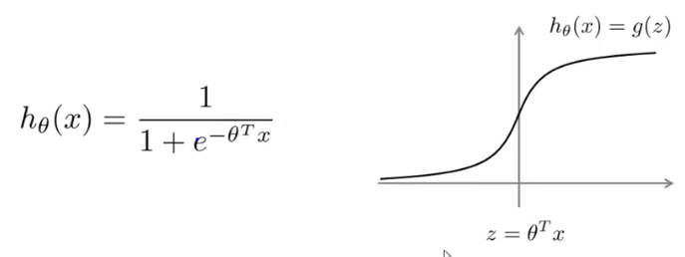

Fig.2 Logistic Regression gradient descent graph

*Pros:*

1. Can do some element designing to transform most non-straight highlights into direct pretty effortlessly.

2. It is likewise entirely vigorous to clamor and you can evade over fitting and even do highlight choice by utilizing l2 or l1 regularization  
3. Strategic relapse can likewise be utilized as a part of Big Data situations since it is truly productive and can be circulated utilizing, for instance, ADMM (see log reg).

4. The yield can be deciphered as a likelihood: you can utilize it for positioning rather than order.

*Cons:*  
1.No distribution requirement  
2.Compute L2 loss  
3.No variable selection  
4.Not suffer multicollinearity

*3.Support Vector Machine(SVM)*

In machine learning, bolster vector machines (SVMs, likewise bolster vector networks[4]) are administered learning models with related learning calculations that break down information utilized for grouping and relapse examination. Given an arrangement of preparing illustrations, each set apart as having a place with either of two classifications, a SVM preparing calculation manufactures a model that allocates new cases to one class or the other, making it a non-probabilistic parallel direct classifier (in spite of the fact that strategies, for example, Platt scaling exist to utilize SVM in a probabilistic characterization setting). A SVM demonstrate is a portrayal of the cases as focuses in space, mapped with the goal that the cases of the different classifications are partitioned by a reasonable hole that is as wide as would be prudent. New illustrations are then mapped into that same space and anticipated to have a place with a class in light of which side of the hole they fall.

*Pros:*

1.Firstly it has a regularisation parameter, which makes the user think about avoiding over-fitting.

2. Secondly it uses the kernel trick, so you can build in expert knowledge about the problem via engineering the kernel.

3.Thirdly a SVM is characterized by a raised enhancement issue (no nearby minima) for which there are productive strategies (e.g. SMO).

4. Lastly, it is an approximation to a bound on the test error rate, and there is a substantial body of theory behind it which suggests it should be a good idea.

*Cons:*

1. Maybe the greatest impediment of the help vector approach lies in decision of the bit.

2. A second restriction is speed and size, both in preparing and testing.

3.Although SVMs have great speculation execution, they can be horrifyingly moderate in test stage.

B. *Unsupervised Learning Algorithms*

1.*K-Means Clustering*

K-implies grouping is a technique for vector quantisation, initially from flag preparing, that is well known for bunch investigation in information mining. k-implies grouping plans to parcel n perceptions into k bunches in which every perception has a place with the bunch with the closest mean, filling in as a model of the group. This outcomes in a dividing of the information space into Voronoi cells. The issue is computationally troublesome (NP-hard); in any case, there are effective heuristic calculations that are normally utilized and meet rapidly to a neighborhood ideal. These are normally like the desire boost calculation for blends of Gaussian disseminations through an iterative refinement approach utilized by both k-implies and Gaussian blend displaying. Furthermore, they both utilize bunch focuses to demonstrate the information; nonetheless, k-implies grouping tends to discover groups of tantamount spatial degree, while the desire boost instrument enables bunches to have distinctive shapes. The calculation has a free relationship to the k-closest neighbor classifier, a well known machine learning procedure for order that is regularly mistaken for k-implies because of the k in the name. One can apply the 1-closest neighbor classifier on the bunch focuses got by k-intends to arrange new information into the current groups. This is known as closest centroid classifier or Rocchio algorithm.,[5]

Given an arrangement of perceptions (x1, x2, … , xn), where every perception is a d-dimensional genuine vector, k-implies bunching means to parcel the n perceptions into k (≤ n) sets S = {S1, S2, … , Sk} in order to limit the inside group entirety of squares (WCSS) (i.e. fluctuation). Formally, the goal is to find:[6]

(1) where μi is the mean of focuses in Si. This is proportionate to limiting the pairwise squared deviations of focuses in a similar group



(1)

(2) The aggregate fluctuation is consistent, this is likewise proportionate to boosting the squared deviations between focuses in various groups.



(2)

*Pros:*

1) If factors are gigantic, at that point K-Means the greater part of the circumstances computationally quicker than various leveled grouping, on the off chance that we keep k smalls.

2) K-Means deliver more tightly bunches than various leveled grouping, particularly if the groups are globular.

*Cons:*

1) Difficult to foresee K-Value.

2) With worldwide bunch, it didn't function admirably.

3) Different introductory segments can bring about various last groups.

4) It doesn't function admirably with bunches (in the first information) of Different size and Different thickness

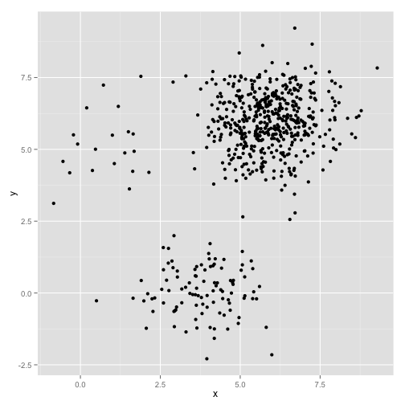

Fig.3 Clustering the data set

2. *Neural Networks*

Fake Neural system is one gathering of calculations utilized for machine discovering that models the information utilizing charts of Artificial Neurons, those neurons are a scientific model that "emulates around how a neuron in the mind functions". In actuality however, the counterfeit neurons for the most part are executed as a non-direct capacity over a straight mix of the info highlights. Numerically: y←f(W.x)y←f(W.x), where W is a network, x is the vector of information highlights and f is a non-direct capacity, as tanh.

There are administered and unsupervised calculations utilizing Artificial Neural Networks, the most usually known is the feed-forward neural system, which is an associated and coordinated chart of neurons, without any cycles that is prepared utilizing the backpropagation calculation, which I won't clarify here, yet is essentially slope drop with the chain run the show. [7] Feed forward and Convolutional systems are regulated models of neural systems. Intermittent Neural systems are charts of neurons with "cycles", that is, a few neurons yields fill in as contributions to themselves. By and by it implies that the information has a variable length and that the yield at one stage fill in as contribution to the following. They are utilized on time-arrangement, since they demonstrate this engendering through time.

*Pros:*

1. Widely used in industry.

2. Many open source implementations.

3. Good to model the non-linear data with large number of

input feature.

*Cons:*

1. Frequently manhandled in situations where less difficult arrangements like straight relapse would be ideal

2. Requires a poop heap of preparing and cases

3. Black box that very little can be gathered from Expanding precision by a couple of percent can knock up the scale by a few sizes.

References

[1] Cohen, J., Cohen P., West, S.G., & Aiken, L.S. (2003). *Applied multiple regression/correlation analysis for the behavioural sciences.* (2nd ed.)

Hillsdale, NJ: Lawrence Erlbaum Associates

[2] Rencher, Alvin C.; Christensen, William F. (2012), "Chapter 10, Multivariate regression – Section 10.1, Introduction", [*Methods of*](https://books.google.com/books?id=0g-PAuKub3QC&pg=PA19)

*Multivariate Analysis*, Wiley Series in Probability and Statistics, 709 (3rd ed.), John Wiley & Sons, p.19, [ISBN](https://en.wikipedia.org/wiki/International_Standard_Book_Number) [9781118391679](https://en.wikipedia.org/wiki/Special:BookSources/9781118391679).

[3] Walker, SH; Duncan, DB (1967). "*Estimation of the probability of an event as a function of several independent variables*". *Biometrika*. **54**:

167–178. [doi](https://en.wikipedia.org/wiki/Digital_object_identifier):[10.2307/2333860](https://doi.org/10.2307%2F2333860)

[4] [Cortes, Corinna](https://en.wikipedia.org/wiki/Corinna_Cortes); Vapnik, Vladimir N. (1995). "Support-vector networks". [*Machine Learning*](https://en.wikipedia.org/wiki/Machine_Learning_(journal)). **20** (3): 273–297. [doi](https://en.wikipedia.org/wiki/Digital_object_identifier):[10.1007/BF00994018](https://doi.org/10.1007%2FBF00994018)

[5] [Kriegel, Hans-Peter](https://en.wikipedia.org/wiki/Hans-Peter_Kriegel); Schubert, Erich; [Zimek, Arthur](https://en.wikipedia.org/wiki/Arthur_Zimek) (2016). "The (black) art of runtime evaluation: Are we comparing algorithms or

implementations?". *Knowledge and Information Systems*. **52**: 341–378. [doi](https://en.wikipedia.org/wiki/Digital_object_identifier):[10.1007/s10115-016-1004-2](https://doi.org/10.1007%2Fs10115-016-1004-2). [ISSN](https://en.wikipedia.org/wiki/International_Standard_Serial_Number) [0219-1377](https://www.worldcat.org/issn/0219-1377)

[6]  E.W. Forgy (1965). "Cluster analysis of multivariate data: efficiency versus interpretability of classifications". *Biometrics*. **21**: 768–769. [JSTOR](https://en.wikipedia.org/wiki/JSTOR)

[2528559](https://www.jstor.org/stable/2528559)

[7] ["*Artificial Neural Networks as Models of Neural Information Processing |* Frontiers Research Topic"](https://www.frontiersin.org/research-topics/4817/artificial-neural-networks-as-models-of-neural-information-processing). Retrieved 2018-02-20.